Linear Regression

The goal of simple linear regression is to create a linear model that minimizes the sum of squares of the residuals / errors (SSE)

<https://www.youtube.com/watch?v=ZkjP5RJLQF4>

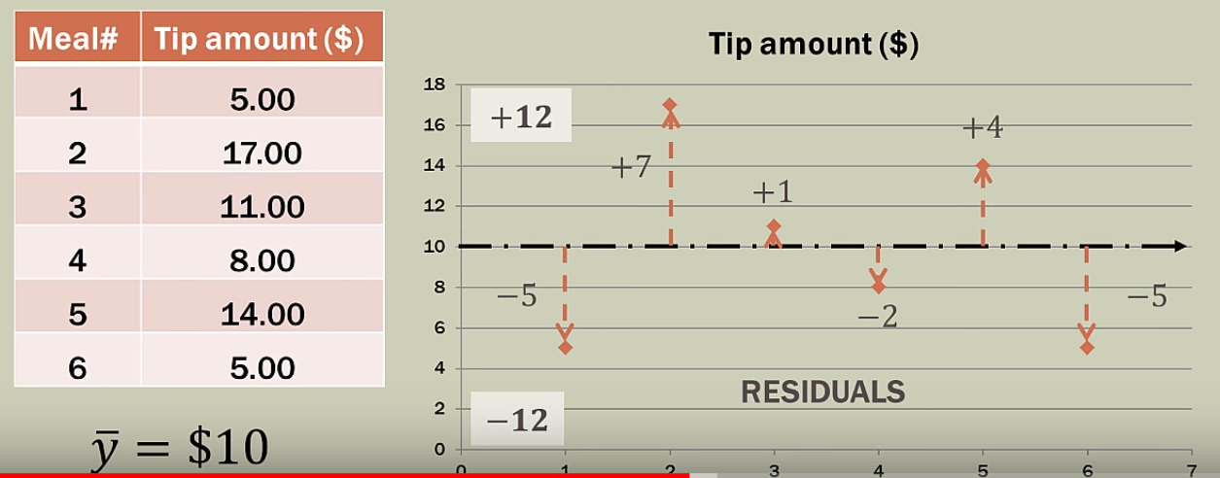

y-bar – mean average

residuals / errors – the distance form real value to its mean value

SSE – Sum of Squared Errors

* Squaring to remove the negativity
* Emphasize larger variations

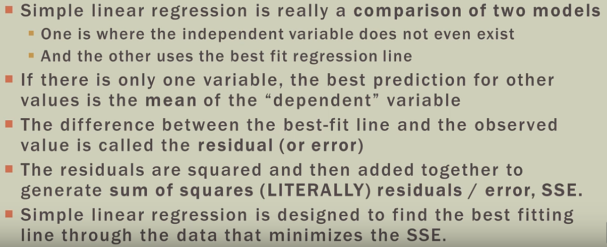

Linear Regression is y = f(x)

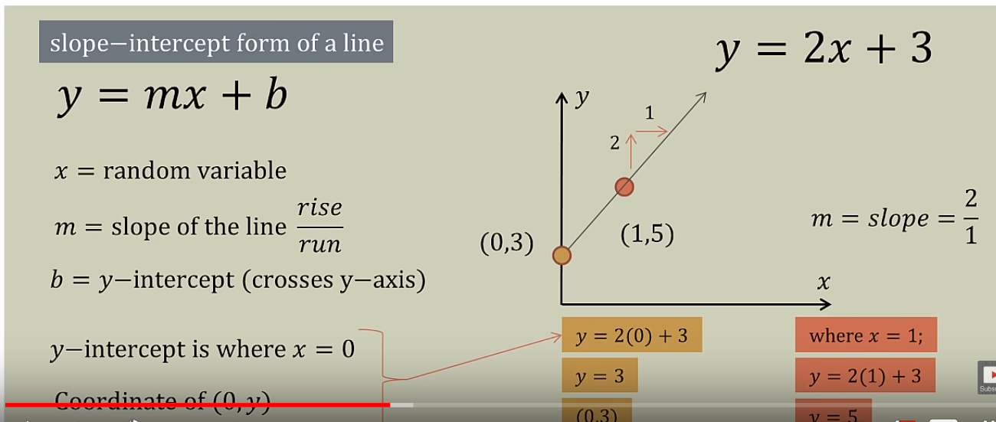

**Variance** is how much a model changes in response to the training data.

**Bias** is the flip side of variance as it represents the strength of our assumptions we make about our data

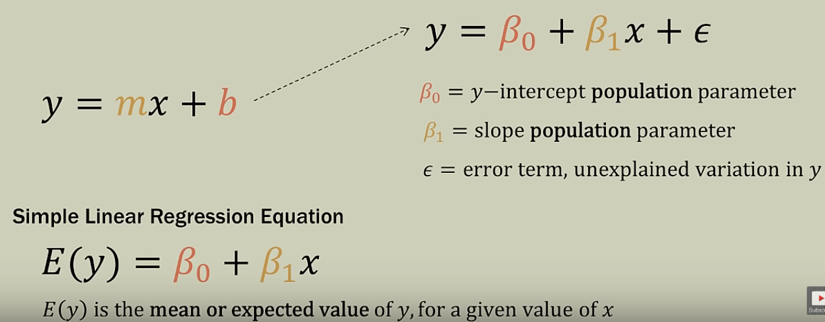

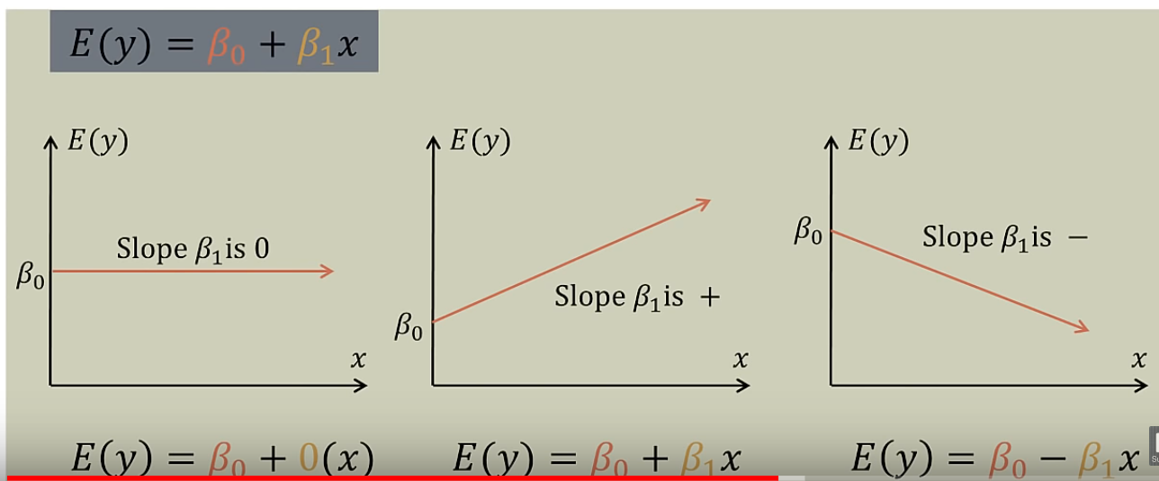

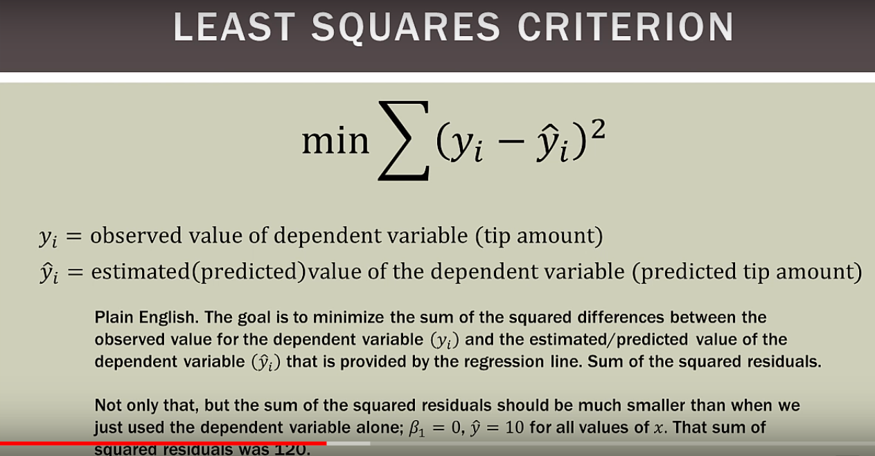

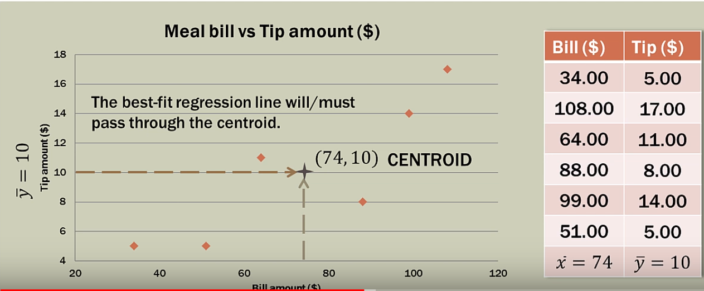

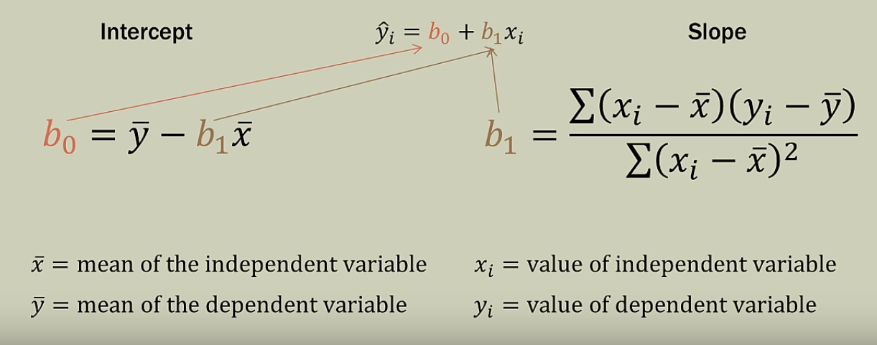

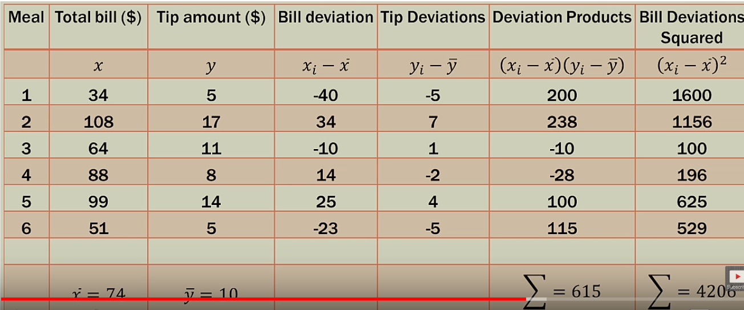

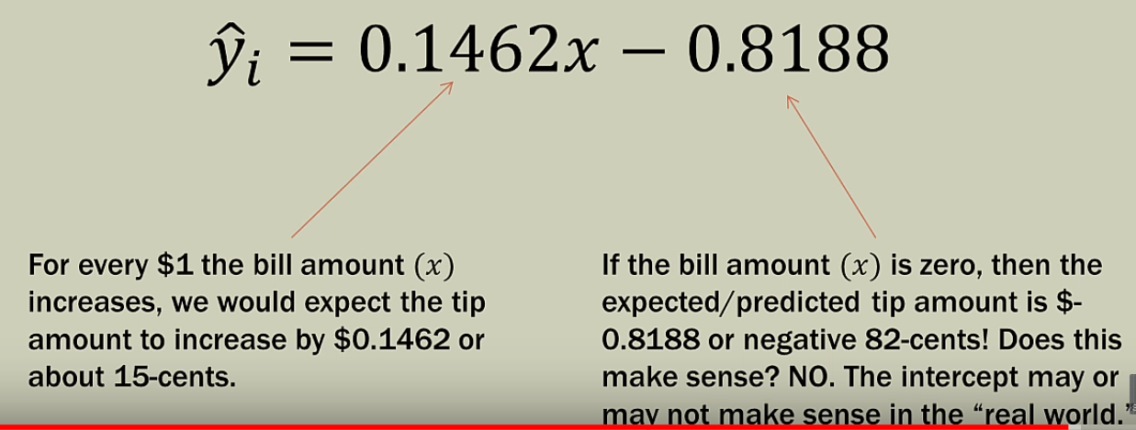

SSE – Sum of Squared Error

SST - Sum of Squared Total

SSR - Sum of Squared Residual

SSR = SST -SSE

